Time Stem Lesson Ladder

PROGRESSION
Essential Foundational Knowledge (Roots) | - Recognize a clock as a measuring instrument  - Order events (before/after; yesterday–today–tomorrow)  - Compare durations informally (longer/shorter)  - Use language to distinguish moment (a point in time) vs duration (how long)
Leads to | - Operations & Equations: modeling unknowns in start/change/end problems; writing and solving one- and two-step equations  - Ratios & Rates  - Graphs & Functions  - Precision with units (science & data): timelines, experiment durations, and data tables that require consistent units
Big Ideas | - Time is continuous [but is it??? -danielle s]  - Moments in time vs. durations of time  - Number systems beyond base 10  - The clock is a wrapped number line  - Composing and decomposing units of time
Other Information | - Always name the unit and the object: “We are subtracting two clock readings to get a duration in minutes.”  - Treat 1 hour is 60 minutes as a unit exchange, not “borrowing” digits.  - Use the straight number line for elapsed time; the circular clock face is for reading moments. Connect the two explicitly (“a wrapped number line”).  - Keep seconds as informal benchmarks before about Grade 4; formal conversions begin in Grade 4+.  - Time is an interesting concept where we use base 12/24/60. Example: If it is 10:00, what time is it in 5 hours. 10, 11, 12, 1, 2, 3. We start over counting after 12.  - Unit exchange: Rewriting the same duration in different units using 1 hour is 60 minutes (and later 1 minute is 60 seconds). This is composing/decomposing units, not digit “borrowing.” Use the language of equivalence here. Equivalent units of time. 60 minutes and 1 hour describe equivalent durations.  - Precision (of reading): The finest unit a reading meaningfully reports (e.g., to the nearest 5 minutes; to the minute). Precision is about the instrument/recording, not about the true duration.

Concept/Skill: Describe and compare the durations of commonplace activities.

Goals | - Use comparative language with time  - Begin to understand time as measurable
Student-Facing Example | 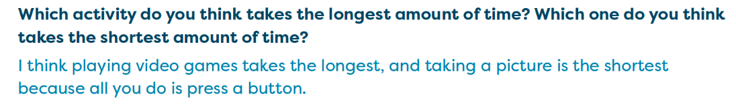  
Knowledge Graph Node | Describe and compare time intervals. | Order events in time and describe their positions.
Terminology
Mathematical Models
Strategies | - Verbally describe and compare durations using longer / shorter, more / less time, and about the same.  - Compare two activities with clear starts and ends side by side, naming which took longer.  - Build intuitive benchmarks from everyday experiences (brushing teeth = short, recess = longer, a movie = long) and use them to estimate new durations. | - Verbally order events using first / next / last and before / after, earlier / later.  - Label positions in a sequence with ordinal words (first, second, third), as in the position-clue and pattern lessons.  - Sequence picture cards of a daily routine or a story — arrange them in order and describe the order aloud.  - Ask before/after questions about familiar routines ("What do we do right after we wash hands? What comes later?").  - G1) Use clock time to settle which event is earlier or later when activities are placed on a schedule.
Specifications | GK:  - -Order activities by duration (GK M1 TG L31-NY Edition; use of ordinal numbers in this lesson)  - -Reasonable vs. unreasonable durations (GK M1 TG L31-NY Edition)  - -Use comparative language (GK M3)  G1:  - -Estimate simple durations (G1 M5 L1 Launch)  G2:  - -Solve real-world duration problems (ex. You have 5 minutes before lunch. Can you finish a 20-minute movie?) (G2 M3 L15) | PreK — Use ordinal numbers (PreK M2 L2, M5 L21, M6)  GK — ordinal-number usage from GK M1 TG L31 (see shared-lesson note below)  G1 — Compare/order schedule events (G1 M6 L23 Launch)
Leaves to Include | - Calendar | Calendar
Considerations | - No clocks yet  - Use everyday experiences to build intuitive benchmarks for short and long durations  - Use activities with clear starts/ends to anchor comparison | - No clocks yet  - Order daily events
Required Skills/Cases | - Compare duration of two activities.  - Order activities from shortest to longest.  - Identify reasonable duration with an activity.  - Determine whether a duration makes sense.  - Use duration vocabulary correctly (longer/shorter, about the same)  - Make a reasonable estimate for how long something takes.  - Determine if activities take about the same amount of time.  - Use duration knowledge to make decisions. | - Compare when two events happen (which is earlier / later).  - Order three or more events in sequence (first to last).  - Identify what comes before / after a given event.  - Compare events from a daily schedule.  - Use ordinal numbers to name an event's position (first, second, third…).  - Determine whether a sequence of events makes sense (e.g., is "we eat dinner, then wake up" reasonable?). [I mean…itsnotwrong… ;) -danielle s]  - Use sequencing vocabulary correctly (earlier/later, before/after, first/next/last).  - Use sequence knowledge to make decisions or answer questions about a schedule.
Misconceptions | - Later means longer.  - More stuff means more time. | - Earlier means shorter (and later means longer)  - Ordinal position is a quantity.
Existing Product Reference, if any | - G2 M3 L15  - Building this into to earlier grades, explicitly, would be new.  - Comparative language taught in GK M3 with comparing length, weight, numbers | - PK M2 TA Lesson 2 — "Use the Clues."  - PK M5 Topic D, Lessons 21–22 — "Create Patterns"  - G1 M5 Topic A, Lessons 1–2 — Tell time to the hour and half hour  - G1 M6 Topic C, Lessons 13–15
Grade (or Leaf) | - PK,K, 1 (foundational)  - 2 (formally introduced durations)
Notes related to Standards, Grade, or Leaf | - IN.2.M.5  - IN.K.M.2  - IA.2.MD.C.IA.1  - IA.PK.7.4.PS.6  - KY.PK.1.4.4  - KY.PK.1.4.5  - SC.PK.MTE-5p  - WI.PK.B.EL.5 not numbered | - IN.2.M.5  - IN.K.M.2  - IA.2.MD.C.IA.1  - IA.PK.7.4.PS.6  - KY.PK.1.4.4  - KY.PK.1.4.5  - SC.PK.MTE-5p  WI.PK.B.EL.5 not numbered
Notes for Intervention, Extension, or Optional Activities | - Cross curricular opportunities within Literacy and embedded in daily routines. | - Cross curricular opportunities within Literacy and embedded in daily routines.
Additional Notes | - Likely 1 instructional period, but can/should be embedded across grade levels | Likely 1 instructional period, but can/should be embedded across grade levels

Concept/Skill: Read and write moments to the hour and half-hour on analog and digital clocks

Goal | Accurately read and record moments, recognizing the roles of the hour and minute hands and using appropriate moment notation
Student-Facing Example | 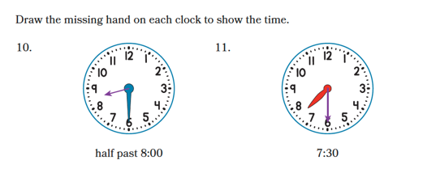  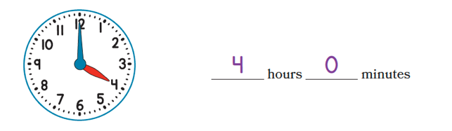  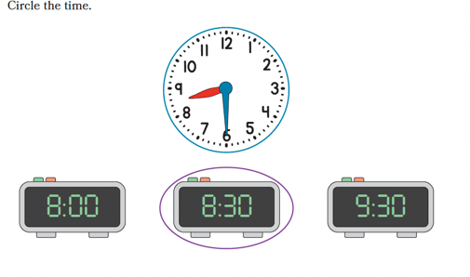
Knowledge Graph Node | Tell and write times to the hour and half hour with analog and digital clocks.
Terminology
Mathematical Models | - Digital and analog clocks  - Number line/path  - Symbolic notation
Strategies | - Connection between clock and the number path  - Connection to composing and decomposing units (60 min to an hour and vice versa)  - Construct a clock by folding a circle
Specifications | - -Identify the hour hand and minute hands on the clock (G1 M1 L17 Launch)  - -Match analog and digital representations (G1 M5 L1, M6 L14 & L15)  - Tell time to hour on analog  - Tell time to half hour on analog  - Tell time to hour on digital  - Tell time to half hour on digital
Leaves to Include | - Calendar
Considerations | - Units of time: seconds, minutes, hours  - Identify hour and minute hands on the clock  - 1 hour is equal to 60 minutes  - Write moments HH:MM (with am/pm if 12h).  - Emphasize moment language; avoid treating moments as durations  - Connect to number line
Required Skills/Cases | - Tell time to hour on analog  - Tell time to half hour on analog  - Tell time to hour on digital  - Tell time to half hour on digital
Misconceptions | - Confuse the hour and minute hand  - Understanding of what each number on the clock represents in hours vs minutes
Existing Product Reference, if any | - G1 M5 and M6 Part 1  - G2 Video: Composing a Day
Grade (or Leaf) | - Grade 1
Notes related to Standards, Grade, or Leaf | - 1.MD.B.3  - CA.1.MD.3  - FL.1.M.2.1  - TX.1.7E  - MD.1.GR.C.5  - NE.K.G.3.b  - AK.K.MD.5
Notes for Intervention, Extension, or Optional Activities | - EM2 GK M1 L28 – Builds the clock  - Fractional understanding of ½ in half hour  - Counting by fives
Additional Notes | - Likely 3-4 instructional periods  - A place that digital could support?

Concept/Skill: Classify times as moments or durations and label both on a timeline

Goal | Distinguish clearly between moment (a single point in time) and duration (length of time)
Student-Facing Example | 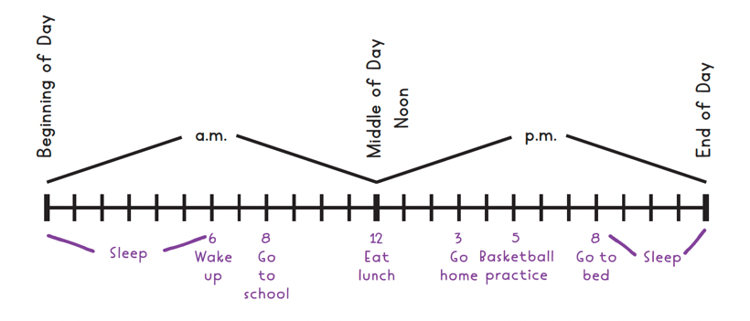
Knowledge Graph Node | Classify times as moments in time or durations of time. | Label the events of a day on a timeline.
Terminology
Mathematical Models | - Digital and analog clocks  - Number line  - Symbolic notation | - Digital and analog clocks  - Number line
Strategies | - Anchor to real-world classroom routines | - Use a physical/kinesthetic timeline (students stand in a line representing events in order)  - Model placing events one at a time, thinking aloud about left = earlier, right = later  - Use the number line — show how clock times map to positions on the line
Specifications | - -Students identify whether information represents a point in time or an amount of time.  - -Examples: "3:00" is a moment.  - "30 minutes" is a duration. | - -Students place moments (events or clock times) on a simple timeline.  - Students place durations on a simple `  - timeline  - -Timeline intervals are ordered.  - -Examples: Place breakfast before lunch, place 3:00 between 2:00 and 4:00.
Leaves to Include
Considerations | - Keep moment vs duration alive in talk, prompts, and rubrics  - Say out loud while pointing: “This point is a moment; this length is a duration.”  - Model think-alouds: “Does this ask when or how long?” Keep moment vs duration alive in talk, prompts, and rubrics  - Say out loud while pointing: “This point is a moment; this length is a duration.”  - Model think-alouds: “Does this ask when or how long?”  - For durations, prefer “45 min” or “1 hr 30 min”; reserve colon notation for moments only to avoid 1:30 vs 1.5 hr confusion.
Required Skills/Cases | - Identify if prompt/example is a moment or a duration | - Place events correctly on a blank timeline  - Identify which event comes before/after another using the timeline
Misconceptions | - Students think a time like "3:00" is a duration rather than a moment ("it lasts 3 hours")  - Students confuse "how long" questions with "what time" questions
Existing Product Reference, if any | - G2 M3 | - G2 M3
Grade (or Leaf) | - Grade 2 | - Grade 2  - Simple examples can come before Grade 2 (similar to first node)
Notes related to Standards, Grade, or Leaf | - AL.PK.MAT4aOP-4  GA.PK.CD-MA3.4d
Notes for Intervention, Extension, or Optional Activities | - Language support needed for A.M and P.M | - -Cross-content connection to historical timelines
Additional Notes | - -Likely 1 instructional period | - -Likely 1 instructional period

Concept/Skill:
- Read and write moments to the nearest 5 minutes
- Use a.m. and p.m.
Goals | - Increase precision in reading moments (nearest 5 minutes).  - Understand that identical clock readings can represent different moments
Student-Facing Example | 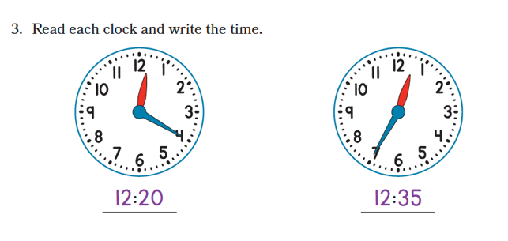  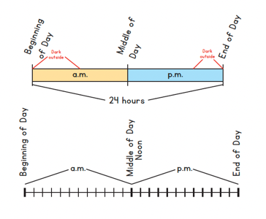
Knowledge Graph Node | Tell and write time to the nearest 5 minutes | - Classify events by using a.m. or p.m.
Terminology
Mathematical Models | - Digital and analog clocks | - Number line
Strategies | - Explicitly connect skip counting by 5s to the clock face before reading time (label the clock with multiples of 5)  - Use a number line alongside the clock to show minute increments as jumps of 5  - Color-code or physically distinguish the hour and minute hands during early instruction  - Think aloud the two-step process: "First I read the hour hand, then I count the minutes by 5s" | - Use a 24-hour timeline (like the one in the student-facing example) to show where noon splits the day  - Start with unambiguous anchor events (waking up = a.m., going to bed = p.m.) before introducing ambiguous cases  - Deliberately use ambiguous examples (e.g., "eating lunch at 12:15 — is that a.m. or p.m.?") to motivate the need for precision
Specifications | - Times are limited to 5-minute intervals only  - Both analog and digital clock formats are required  - Hour range: all 12 hours represented  - Problems should include a mix of "read and write" and "draw the hands" directions | - Avoid using "morning" or "night" as context clues — students should reason from the time itself  - 12:00 noon and 12:00 midnight should be explicitly addressed as edge cases  - Events should be culturally familiar and age-appropriate (school, meals, sleep, sports)
Leaves to Include
Considerations | - Use number line connections to explain minute increments.  - Dual meaning of the large numbers on an analog clock: they represent the hour when reading the hour, and they represent groups of 5 minutes when reading the minutes (1 five, 2 fives, 3 fives, … , 12 fives) | - Provide examples of ambiguous moments to motivate a.m./p.m.
Required Skills/Cases | - read a variety of clocks and write the time  - given a digital time, draw hands on a blank clock face  - given an analog clock, write the time | - given a described event, identify whether it occurs in a.m. or p.m.  - given ambiguous events (e.g., "eating a meal"), justify the classification with reasoning
Misconceptions | - Students read the minute hand as the number it points to rather than multiplying/skip counting by 5 (e.g., reads "4" as 4 minutes instead of 20 minutes)  - Students confuse which hand is the hour vs. minute hand  - Students don't recognize that the large numbers serve a dual purpose (hours AND groups of 5 minutes) | - Students think a.m. means morning and p.m. means night, without understanding the 12-hour cycle, confusing 12 a.m and 12 p.m
Existing Product Reference, if any | - G2 M3 | - G2 M3
Grade (or Leaf)
Notes related to Standards, Grade, or Leaf
Notes for Intervention, Extension, or Optional Activities |  | - Use a personal daily schedule anchor chart the student builds themselves (wake up, eat breakfast, school, dinner, bed) as a reference tool  - Introduce 24-hour/military time as a system that eliminates the a.m./p.m. ambiguity  - Explore time zones and how the same clock time can be a.m. in one place and p.m. in another
Additional Notes | - -Likely 2 instructional periods | - -Likely 1 instructional period

Concept/Skill: Measure durations with a timing tool and estimate durations with time benchmarks.
Goal | Use meaningful time benchmarks (≈1 second, ≈1 minute, ≈15 minutes) to develop a sense of reasonableness
Student-Facing Example | 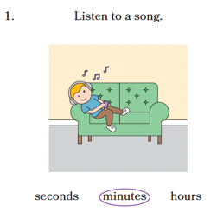
Knowledge Graph Node | Measure the duration of an activity with a timing tool. | Estimate durations by using time benchmarks and determine whether estimated durations are reasonable.
Terminology
Mathematical Models | - Stopwatches, timers  - Symbolic notation | - Digital and analog clocks  - Number line  - Symbolic notation
Strategies
Specifications | - Focus on duration (elapsed time), not telling time  - Do not include calculating elapsed time (e.g., solving for unknown start, end, or elapsed time)  - Read and record the duration with the correct unit | - Focus on durations that can be directly experienced and internalized (e.g., seconds to about 30 minutes)  - May include durations up to 1 hour for comparison (e.g., Does this take about 15 minutes or 1 hour?)  - Select the correct units for estimations (about 1 minute vs about 1 second)
Leaves to Include
Considerations | - Always name the unit of duration when estimating | - Always name the unit of duration when estimating  - Use real tasks (jumping jacks, reading a page) to anchor benchmarks
Required Skills/Cases | - Read and record a duration shown on a timing tool  - Identify the unit displayed (seconds vs. minutes)  - Record a measured duration in symbolic notation (e.g., 23 seconds) | - Establish benchmarks (≈1 second, ≈1 minute, ≈15 minutes)  - Estimate duration of an activity (include everyday tasks)  - Choose appropriate unit for duration  - Identify reasonable vs unreasonable estimates  - Compare two durations  - Order activities by duration
Misconceptions | - A clock can be used to measure durations the way a timer can (confusing reading a moment with measuring a duration) | - Larger numbers mean a longer task without regard to units (e.g., 60 seconds is longer than 3 minutes because 60 is greater than 3)
Existing Product Reference, if any | - EM2 G2 M3 L15 Learn 2: Estimate and Measure Time | - EM2 G2 M3 L15 Learn 2: Estimate and Measure Time
Grade (or Leaf) | 1, 2 | 1, 2
Notes related to Standards, Grade, or Leaf | MD.1.GR.C.5  In EM2, this work is noted as being foundational to 2.MD.C.7 | MD.1.GR.C.5  In EM2, this work is noted as being foundational to 2.MD.C.7
Notes for Intervention, Extension, or Optional Activities | - Extension: measure the same activity twice and compare results; discuss why readings might differ | - Intervention: stopwatch activities (measure vs estimate)  - Extension: include additional benchmarks or estimate longer durations
Additional Notes | Likely part of an instructional period  Assessment note: the physical act of operating a timer is best observed in instruction; items should present a completed timer reading for students to interpret and record (OARS) | Likely part of an instructional period

Concept/Skill: Tell and write time to the nearest minute.
Goals | - Read and record moments with one-minute precision  - Strengthen the relationship between clocks and number lines
Student-Facing Example | 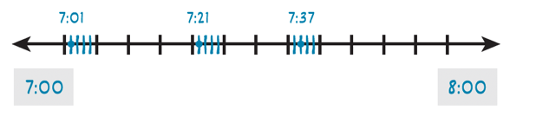  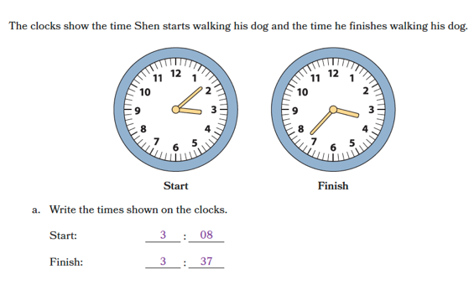
Knowledge Graph Node | Tell and write time to the nearest minute.
Terminology
Mathematical Models | - Digital and analog clocks  - Number line  - Symbolic notation
Strategies
Specifications
Leaves to Include | - Half past, quarter past/after, quarter to/until
Considerations | - Reinforce that the clock is a wrapped number line.  - Guard against interpreting 1:30 as a duration (1.5 hours); reinforce moment notation
Required Skills/Cases | - Include times:  - on the hour and half hour  - on 5-minute marks  - between 5-minute marks  - close to the next hour  - Use a.m. and p.m.
Misconceptions | - The hour is the number the hour hand is closest to (naming the next hour instead of the current hour when the hour hand is between numbers)  - Times on the hour, half hour, and 5-minute marks are not to the nearest minute (e.g., clock shows 4:05 but a student doesn’t think they can write that time when asked for the time to the nearest minute)
Existing Product Reference, if any | - EM2 G3 M6 L2
Grade (or Leaf) | 3 (2 for some states)
Notes related to Standards, Grade, or Leaf | CCSS.3.MD.A.1  CA.3.MD.1  FL.3.M.2.1  TX.2.9G  MD.2.GR.C.7  PA.M04.D-M.1.1.4 (identify time as the amount of minutes before or after the hour)
Notes for Intervention, Extension, or Optional Activities | - Optional: ___ until the next hour and ___ past the current hour (e.g., 10 ‘til 3 and 10 past 2)
Additional Notes | Likely 1 instructional period

Concept/Skill: Represent and solve elapsed time problems by using the number line.
Goals | - Use the number line to model start/elapsed/end relationships  - Use unit exchanges flexibly when crossing hours  - Apply start/elapsed/end unknown reasoning across several steps  - Use estimation to check the reasonableness of answers
Student-Facing Example | 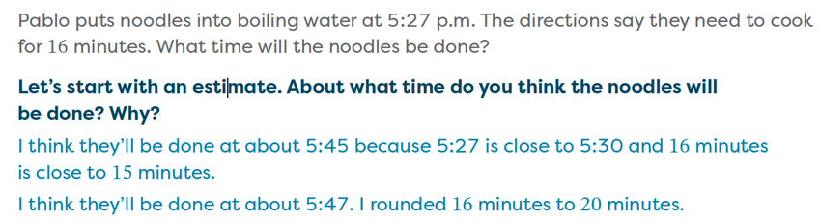  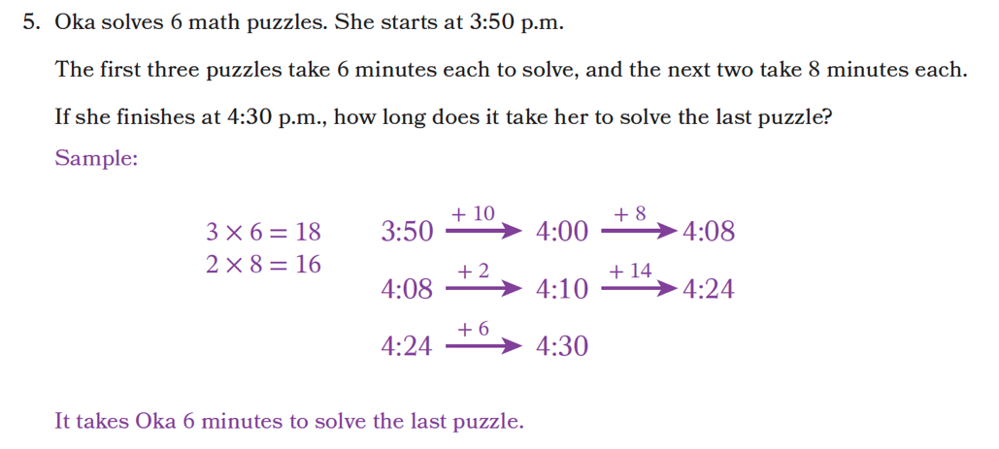  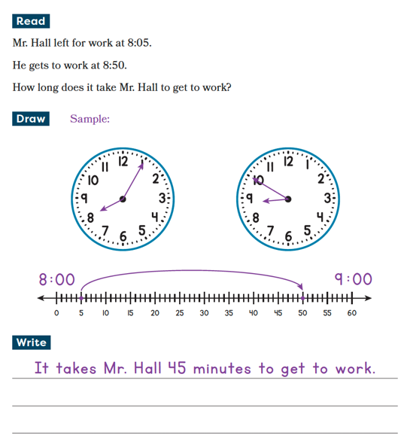
Knowledge Graph Node | Represent and solve elapsed time problems by using the number line.
Terminology | - Elapsed time: The duration between two moments on the same time scale.
Mathematical Models | - Digital and analog clocks  - Number line  - Symbolic notation
Strategies
Specifications | - Do not require conversions (e.g., an answer of 75 minutes is acceptable)  - Do not include multi-day/crossing midnight  - Estimate duration before solving and compare to exact answer  - Include like and mixed unit problems
Leaves to Include | - Types of problems (start/elapsed/end unknown)
Considerations | - Label endpoints and jumps with units (e.g., +15 min, +10 min)  - For elapsed time, draw a straight timeline first; use the clock face only to read a moment. Call the clock a “wrapped number line.”  - Use earlier/later (not before/after alone) when computing on a timeline  - Include across-hour and within-hour cases; include across noon occasionally; save across midnight for later  - When crossing an hour, show the unit exchange move explicitly  - Normalize unit decomposition/composition in simple cases: trade 1 hr for 60 min  - Spiral story contexts with small and large durations; avoid only “school schedule” vibes  - Ask students to explain the operation using the timeline (“I subtracted the earlier moment from the later moment to get the duration”)  - Opportunities for a quick estimate before exact work; reject answers that violate the estimate (“3 minutes for a movie?”)  - Mix start/elapsed/end unknown types deliberately; don’t let one dominate  - When rounding time, say what you’re rounding (moment vs duration) and to what unit.
Required Skills/Cases | - Include problems:  - to the hour and half hour  - within hour  - across hour  - across noon occasionally  - (not across midnight)  - Save across midnight for later  - Problem types (include one- and multi-step problems):  - Unknown end time  - Unknown start time  - Unknown elapsed time  - Unknown total elapsed time across multiple intervals  - Unknown intermediate time  - Unknown end time after multiple elapsed intervals  - Unknown start time given later times and elapsed intervals  - Estimate durations and use estimates to check the reasonableness of answers:  - Check whether the unit makes sense (e.g., 3 minutes vs 3 hours)  - Check reasonableness of within hour durations, across hour durations, and multistep durations  - Explain why an answer is reasonable or unreasonable
Misconceptions | - Time works like base-10 numbers; students try to add/subtract times without accounting for base-60 structure  - Multistep means add everything; students combine all intervals without attending to what the problem is asking  - Students accept answers with unreasonable units; not attending to the unit when assessing reasonableness
Existing Product Reference, if any | - EM2 G3 M6 L3-L5 (number line representations)  - EM2 G3 M6 L6: Learn 1: Word Problems Involving Time  - EM2 G3 M2 L12 Extit Ticket  - EM2 G3 M6 L3 (estimate elapsed time)
Grade (or Leaf) | 3 (2, 4 for some states)
Notes related to Standards, Grade, or Leaf | CCSS. 3.MD.A.1  CA.3.MD.1  FL.3.M.2.2  FL.4.M.2.1  TX.3.7C (problems can include adding time intervals in minutes, unknown end time, or unknown start time; can’t include unknown elapsed time)  TX.4.8C  AK.4.MD.4 (specifies across time zones)  AK.5.MD.2 (specifies across world time zones)  MD.2.GR.C.8 (limited to hour and half hour)  ND.3.GM.M.4 (limited to hour and half hour)  NC.4.MD.8  OK.4.GM.3.1  SC.4.MGSR.2.2  VA.3.MG.3.c.i, ii, iii (specifies one-hour increments within a.m. or p.m.)
Notes for Intervention, Extension, or Optional Activities | - Intervention:  - Solve problems within 1 hour on a number line that has tick marks for each minute  - Revisit benchmarks (e.g., about 1 minute, about half an hour)  - Optional/extension: Create a word problem where the solution is a given elapsed time  - Extension: build a schedule from given constraints
Additional Notes | Likely 2 instructional periods

Concept/Skill: Convert between time duration units.
Goal | - Understand that conversions represent the same duration in different units  - Build fluency with conversions across multiple units when solving complex problems
Student-Facing Example | 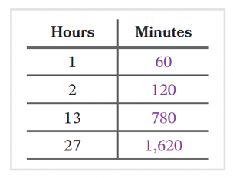
Knowledge Graph Node | Convert larger units of time duration to smaller units. | Convert smaller units of time duration to larger units. | Solve multistep problems by converting between units of time duration.
Terminology
Mathematical Models | - Number line  - Conversion tables | - Number line  - Conversion tables | - Number line  - Conversion tables
Strategies
Specifications | - Larger units smaller units  - Units: Hours, minutes, and seconds  - Exact conversions (e.g., 2 hours 12o minutes)  - Mixed unit conversions (e.g., 2 minutes 15 seconds 135 seconds)  - Convert units (largersmaller) when needed to operate or interpret the answer  - Follow G4 specifications for adding/subtracting simple fractions and decimals  - For G4, multiplication of whole number by fraction is allowed; no fraction division or decimal multiplication/division  - Include multiplicative comparison language depending on where this lands in the G4 year-long sequence | - Smaller units larger units  - Units: Hours, minutes, and seconds  - Exact conversions (e.g., 120 minutes 2 hours  - Mixed unit conversions (e.g., 75 minutes 1 hour 15 minutes)  - Convert units (smallerlarger) when needed to operate or interpret the answer  - Follow G4 specifications for adding/subtracting simple fractions and decimals  - For G4, multiplication of whole number by fraction is allowed; no fraction division or decimal multiplication/division  - Include multiplicative comparison language depending on where this lands in the G4 year-long sequence | - Largersmaller  - Smallerlarger  - Units: seconds, minutes, hours, days  - Include mixed units
Leaves to Include
Considerations | - Emphasize decomposing units  - Maintain clear distinction between durations and moments  - Can include problems involving simple fractions or decimals  - Problems that require conversions between units of time  - Understand when to decompose durations to operate efficiently | - Emphasize composing units  - Understand when to compose durations to operate efficiently | - Work flexibly with mixed/decimal hours (e.g., 1.5 hr is 1 hr 30 min) when contexts demand  - Conversions can be from larger to smaller units and from smaller to larger units  - Interpret and create graphs of a quantity vs. time; reason qualitatively about (proto) rate (steeper is faster).  - Proto Rate. A comparison of a quantity per unit of time (e.g., miles per hour), built from tables/graphs rather than a stand-alone formula at this grade band.
Required Skills/Cases | - Know unit relationships  - Convert hours to minutes and minutes to seconds  - Mixed unit conversions  - Use the four operations to solve word problems involving durations:  - Add durations to find total time  - Subtract durations to find a difference or remaining time  - Multiply a duration by a whole number to find repeated time  - Divide a duration:  - by a whole number to find equal shares  - by a duration to find the number of equal intervals  - Covert a duration (largersmaller)  - Solve multistep duration problems involving more than one operation | - Know unit relationships  - Convert seconds to minutes and minutes to hours  - Mixed unit conversions  - Use the four operations to solve word problems involving durations:  - Add durations to find total time  - Subtract durations to find a difference or remaining time  - Multiply a duration by a whole number to find repeated time  - Divide a duration:  - by a whole number to find equal shares  - by a duration to find the number of equal intervals  - Covert a duration (largersmaller or smallerlarger)  - Solve multistep duration problems involving more than one operation | - Convert (no context); largersmaller and smallerlarger  - Complete conversion table; largersmaller and smallerlarger  - Solve word problems involving conversions  - Solve word problems involving mixed representations (decimals/fractions) and mixed units  - Interpret and create graphs of a quantity vs. time
Misconceptions | - Changing the unit changes the duration  - Time conversions work like metric unit conversions (students apply powers of 10)  - Moments and durations can be operated on the same way; students treat clock times like durations of time (e.g., multiplying 3:15 by 2) | - The number should always get larger when converting | - Converting between units always involves multiplying (when converting units, the number should always get larger)
Existing Product Reference, if any | - EM2 G4 M3 L18 |  | - EM2 G5 M3 L5; Launch and Conversions in the Real World  - EM2 G5 M6 L16; Tara’s Piano Practice and Kelly’s Road Trip  - EM2 G5 M6 L18; Comparing Line Graphs
Grade (or Leaf) | 4 (5 for SC) | 4 (5 for SC) | 5
Notes related to Standards, Grade, or Leaf | CCSS. 4.MD.A.2  CA.4.MD.2  FL.4.M.1.2  FL.4.M.2.1  TX.4.8B  TX.4.8C  OK.4.GM.3.2  GA.4.MDR.6.1  SC.5.MGSR.2.1 | FL.4.M.1.2  FL.4.M.2.1  TX.4.8B  TX.4.8C  OK.4.GM.3.2  GA.4.MDR.6.1  SC.5.MGSR.2.1 | CCSS.5.MD.A.1  CA.5.MD.1  FL.5.M.1.1  TX.4.8B  TX.5.7A  GA.5.MDR.7.4  SC.5.MGSR.2.1  SD.5.MD.A.1
Notes for Intervention, Extension, or Optional Activities | - Extension: include conversions with larger units (e.g., days to hours, weeks to days) | - Intervention: use ‘groups of’ language (e.g., How many groups of 60 are in 75?)  - Extension: include conversions with larger units (e.g., days to hours, weeks to days)
Additional Notes | Likely parts of multiple instructional periods | Likely parts of multiple instructional periods | Likely part of an instructional period

